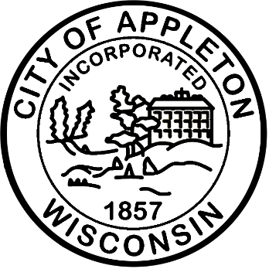

City of Appleton
Parks and Recreation Deputy Director

Come join the City of Appleton! Here at the City, you’ll have the opportunity to grow and enjoy your best life through challenging work, great teams, training opportunities, and making a lasting impact on the community. We welcome and respect all employees as they are. Come join our team—you belong here!
The City of Appleton is accepting applications for a full-time Deputy Director of Parks & Recreation. This is a management position responsible for providing strategic leadership and operational oversight for the Parks, Recreation, Facilities Management, and Reid Golf Course divisions. The position provides direction and support to division managers, leads departmental planning and initiatives, oversees operating and capital budgets, and evaluates programs and services to ensure they effectively meet community needs. The position also works closely with City departments, community organizations, contractors, and other partners on capital projects, policies, grants, contracts, and service improvements. The incumbent works under the general direction of the Director of Parks & Recreation.

Qualifications
This position requires a bachelor’s degree in Recreation, Parks Administration, Public Administration, Business Administration, Facilities Management, or a related field and a minimum of six years of progressively responsible parks and recreation administrative experience, or an equivalent combination of education, experience, and training. The ideal candidate will have supervisory and leadership experience, knowledge of parks, recreation, golf operations, and facilities management, and the ability to develop strategic plans, manage budgets, evaluate operations, build effective partnerships, and communicate effectively with City officials, employees, and the public. The ability to maintain a valid driver’s license is required.

Salary
The salary range for this position is $85,134 - $127,712 annually plus an excellent fringe benefit package including: paid time off; health, dental and vision insurance; free employee health clinic and coach; life insurance; short-/long-term disability insurance; accident insurance; on-site fitness center; health and wellness programs; post-employment health plan; deferred compensation; and Wisconsin Retirement System (WRS). We are proud to share the WRS is among the best funded and best managed public pension systems in the country!

Apply Now!
If you are interested in applying for this position, please complete an on-line application at www.appletonwi.gov/careers by no later than Saturday, September 20, 2026. Resumes without an application will not be considered.

City of Appleton Human Resources
100 N. Appleton Street, 6th floor
Appleton, WI 54911
Phone: (920) 832-6458
Email: humanresources@appletonwi.gov
Equal Opportunity Employer

